ASSIGNMENT 13

Terraform variables and Terraform output (public_ip, private_ip, key pair)

TERRAFOM VARIABLES :

Terraform.tfvars :
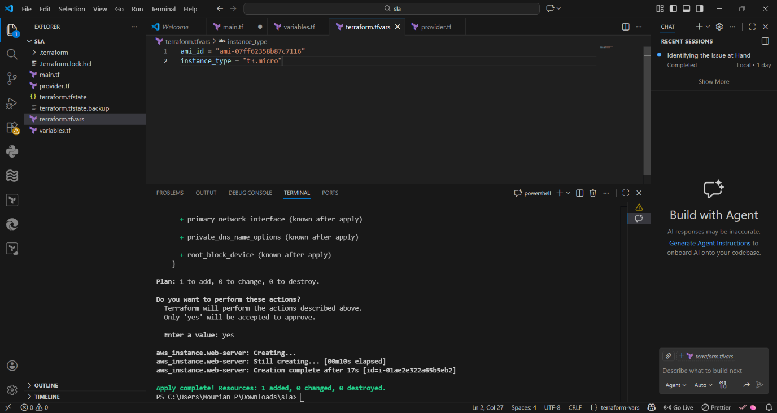

Variables.tf :
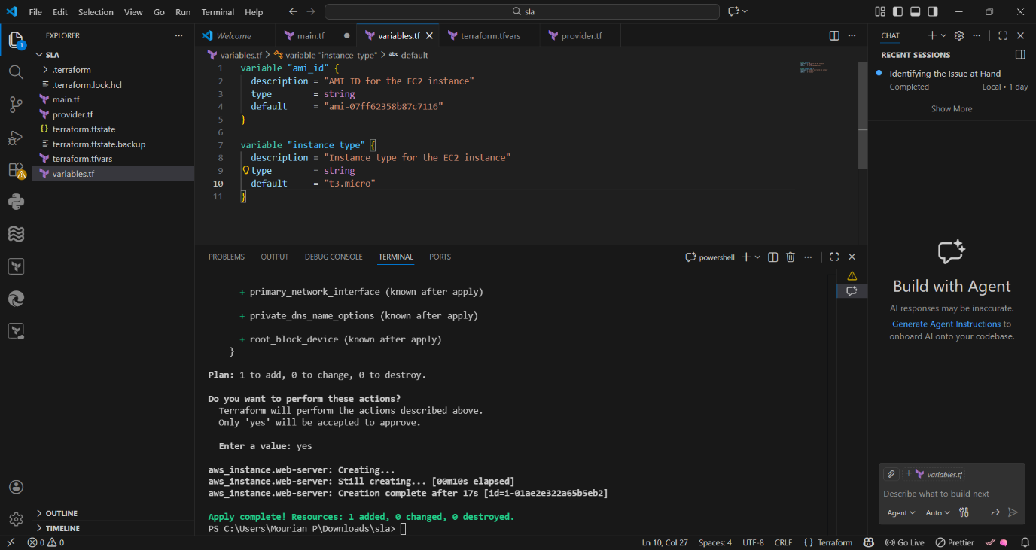

Main.tf :
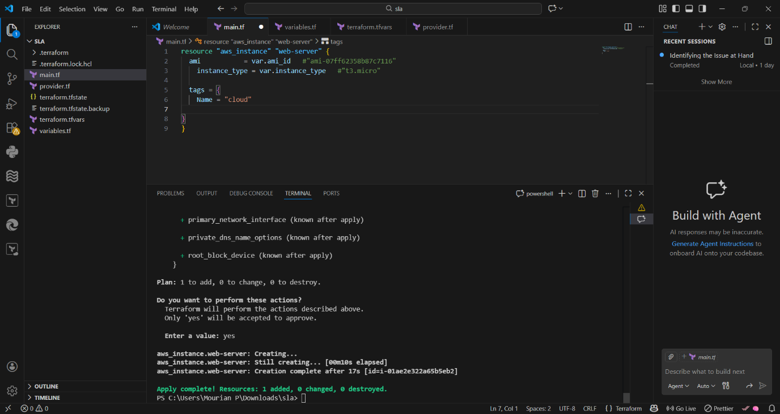

1️⃣ terraform.tf
Explanation:
Used to define tool settings (like provider and region).
It tells Terraform how and where to work.
Python example (configuration style):
# terraform.tf equivalent in Python
PROVIDER = "AWS"
REGION = "ap-south-1"

2️⃣ main.tf
Explanation:
Used to define and create resources (EC2, VPC, etc).
This is the main infrastructure logic file.
Python example (resource creation):
# main.tf equivalent in Python
def create_ec2(ami_id, instance_type):
print("EC2 created with", ami_id, instance_type)

create_ec2(AMI_ID, INSTANCE_TYPE)

3️⃣ terraform.tfvars
Explanation:
Used to store variable values separately.
Makes code reusable and easy to change.
Python example (variable values):
# terraform.tfvars equivalent in Python
AMI_ID = "ami-0abcd1234"
INSTANCE_TYPE = "t2.micro"

Terraform output (public_ip, private_ip, key pair)

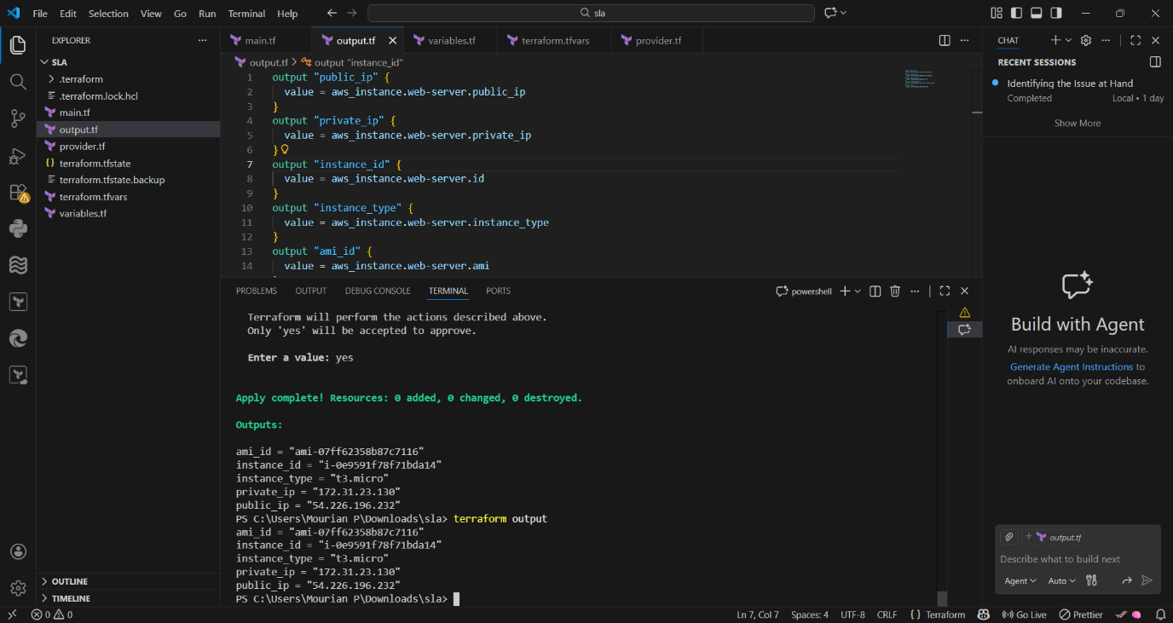

output.tf:
Explanation;
output.tf is used to display important information about created resources after terraform apply.
It shows values like AMI ID, Instance ID, Instance Type, Private IP, and Public IP.
These outputs help users verify resources and reuse values in other Terraform modules.

What output.tf shows
- AMI ID → Which AMI is used
- Instance ID → Unique EC2 instance ID
- Instance Type → Size of the instance
- Private IP → Internal network IP
- Public IP → Internet-facing IP

Terraform output.tf example
output "ami_id" {
value = aws_instance.my_ec2.ami
}

output "instance_id" {
value = aws_instance.my_ec2.id
}

output "instance_type" {
value = aws_instance.my_ec2.instance_type
}

output "private_ip" {
value = aws_instance.my_ec2.private_ip
}

output "public_ip" {
value = aws_instance.my_ec2.public_ip
}

Python example (output display logic)
# output.tf equivalent in Python

ami_id = "ami-0abcd1234"
instance_id = "i-0a1b2c3d4e"
instance_type = "t2.micro"
private_ip = "172.31.10.15"
public_ip = "13.235.80.120"

print("AMI ID:", ami_id)
print("Instance ID:", instance_id)
print("Instance Type:", instance_type)
print("Private IP:", private_ip)
print("Public IP:", public_ip)

